Project Screen:

1. Add Project-There is no back button, need to add.
2. Add Project-Need to remove scroll option.
3. Overview-Proj description and roles are overlapping.

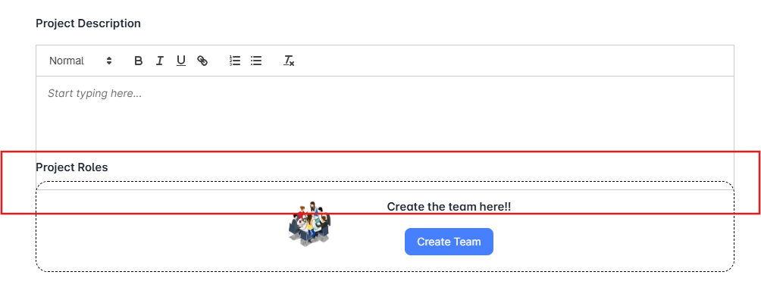

1. Overview-Proj description-After enter valid details and click anywhere, text box is not closed automatically.
2. Overview-File upload-”+” symbol should present in the middle of the box.
3. Overview-File upload-Need to add the details what kind files user can upload.
4. Overview-Create Team-When mouse hover to the default email & Add Team, the predefined text and tool tip text is different.
5. Overview-Create Team-Without select any details and click update button, no alert message is displayed.(Need to add mandatory fields).
6. Overview-Create Team-Close button alignment is not proper.
7. Overview-Create Team-Default email is empty.
8. Overview-Create Team-After add valid details in add team and lead name and click update button, success message is displayed but pop up is not closed automatically.
9. Overview-Create Team-Overall, user cannot able to create a team.
10. Overview-Create Team-Overall, user cannot able to create goal
11. Kanban Board-Create-Assignee and Reporting to dropdown details are empty.
12. Kanban Board-Edit a task-Click time tracking and when mouse hover to the time spent field, tool tip text displayed “Please fill out this field” message, but it should display valid message.
13. Kanban Board-Cannot able to create a task, after enter valid details and click save button, page shows “null details are created” message.
14. Kanban Board-Eidt Task-There is no update button.

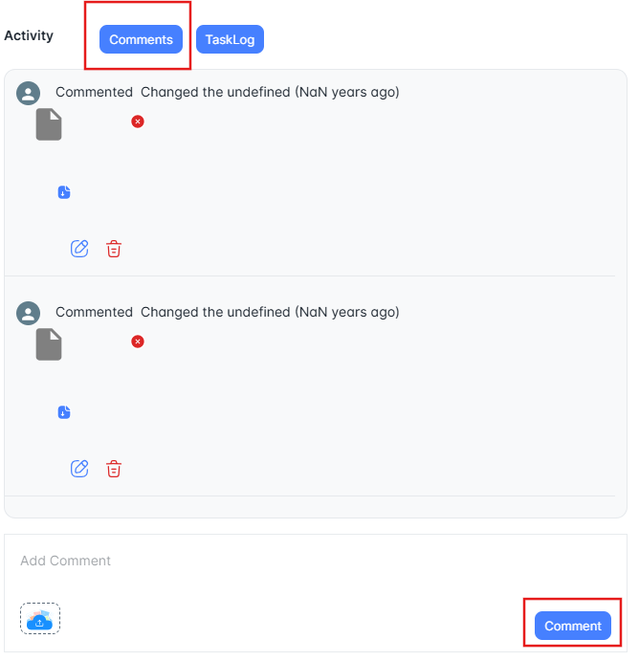

1. Dashboard-For CGI project-Author name is not displayed.